**February 19**

Creating repo, creating team, first discussions [ALL (online)]

**February 24**

Dataset chosen: [Temperature change](https://github.com/stacyshki/TemperatureChangeVisualization/blob/main/Environment_Temperature_change_E_All_Data_NOFLAG.csv) [ALL (online)]

README created [Viktor Korotkov]

**February 25**

Project discussion and plan visualization [ALL (offline)]

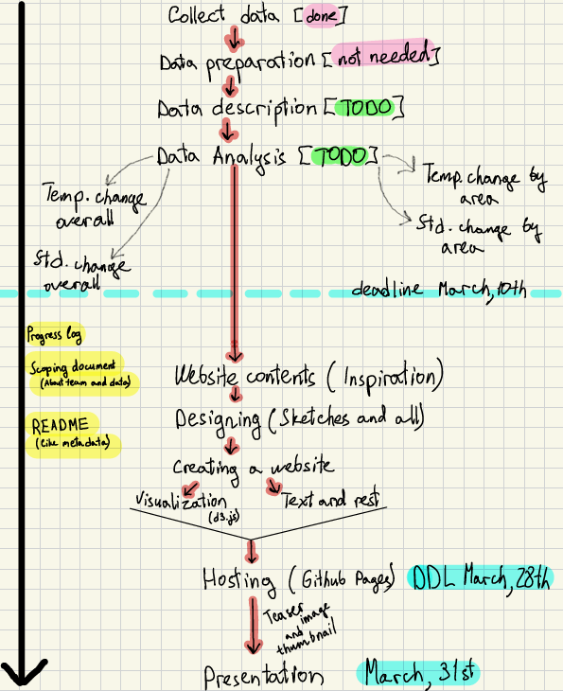

We decided to neglect missing values in the data and didn’t drop rows with them due to specifics of the data

**March 5**

Processing temperature data [Shitao Zhao]

Processing standard deviation data [Shitao Zhao]

Temperature change & std analysis [Shitao Zhao & Viktor Korotkov]

**March 8**

Descriptive analysis [Viktor Korotkov]

Geographical analysis [Viktor Korotkov]

Seasonal analysis [Viktor Korotkov]

Code review [ALL (online)]

**March 9**

Correlation analysis [Shitao Zhao]

Updated visualized plan:

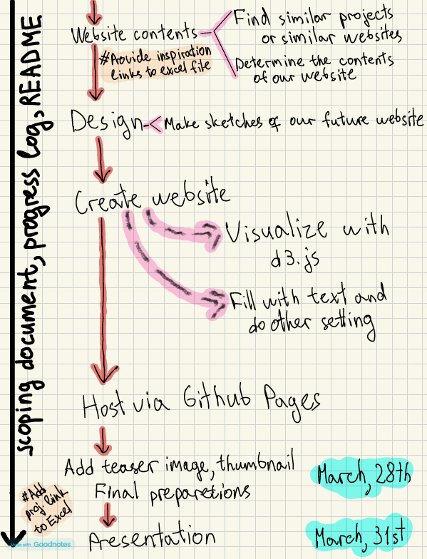

**March 12**

Geomap added (Python analysis) just for it to be [Viktor Korotkov]

Find similar projects [ALL (online discussion)]

Website design [ALL (online discussion)]

**March 13**

Raw webpages created [Arystan Kamalov]

### TODO: website contents, PHOTOS, creation of website, hosting, images, final checks, README, SCOPING DOCUMENT